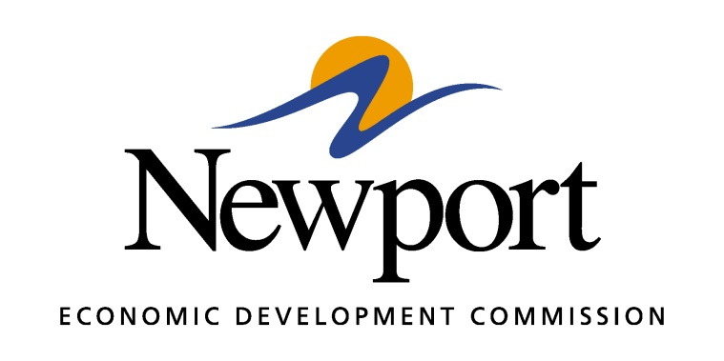

AGENDA
May 10, 2018
Meeting Held at Gränges (former Norandal Plant)
- Open Meeting
- Approval of Minutes
- Approval of Financial Report
- Executive Director’s Report
- Director of Chamber Affairs’ Report
- ReNewport Grants
- Incentives for Gränges Project
- Hotel Feasibility Study
- PPM Consultants Program
- Employee Resignation
- Opportunity Zone
- Non-Resident Employee Survey
- Night at the Ballgame
- White River Port Prospect
- Adjourn

