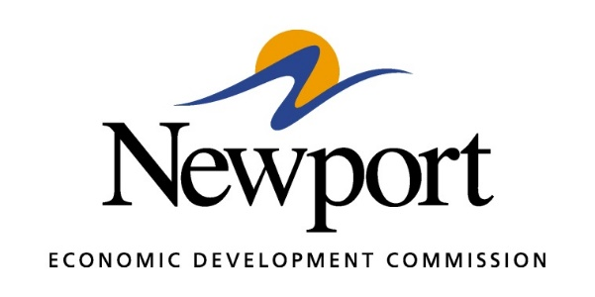

AGENDA
TUESDAY - May 14, 2019
Meeting at Newport Economic Development Commission Office

- Open Meeting
- Approval of Minutes
- Approval of Financial Report
- Executive Director’s Report
- Director of Chamber Affairs’ Report
- ReNewport Grants
- Unity/ASU-Newport Nursing Building Update
- Ever Corporation Property
- Prospect Activity
- Medical Marijuana Facilities Update
- MOST Update
- AAIMS AP Training Funding Request
- EDA Grant Update
- Gränges Water Line Update
- Adjourn Meeting

