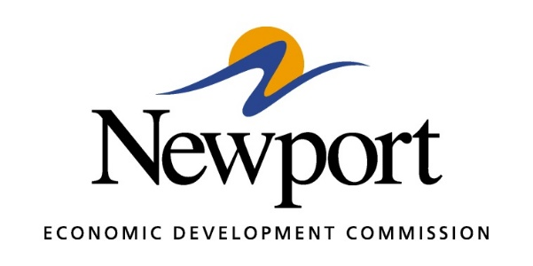

AGENDA
OCTOBER 8, 2019
Meeting at Newport Economic Development Commission Office
- Open Meeting
- Approval of Minutes
- Approval of Financial Report
- Executive Director’s Report
- Director of Chamber Affairs’ Report
- ReNewport Grants
- ACT Workready Community
- Lighting Project
- Clean Up Proposal

- Entertainment District
- Annual Strategic Plan Draft
- Adjourn Meeting

